|  |  |
| --- | --- |
| Nama : | Putri Rachel Geby Tampubolon |
| NIM : | 12S20008 |
| Kelas : | 13SI1 |
| Matkul : | Gudang Data dan Kecerdasan Bisnis |

**Implementasi ETL**

1. Staging

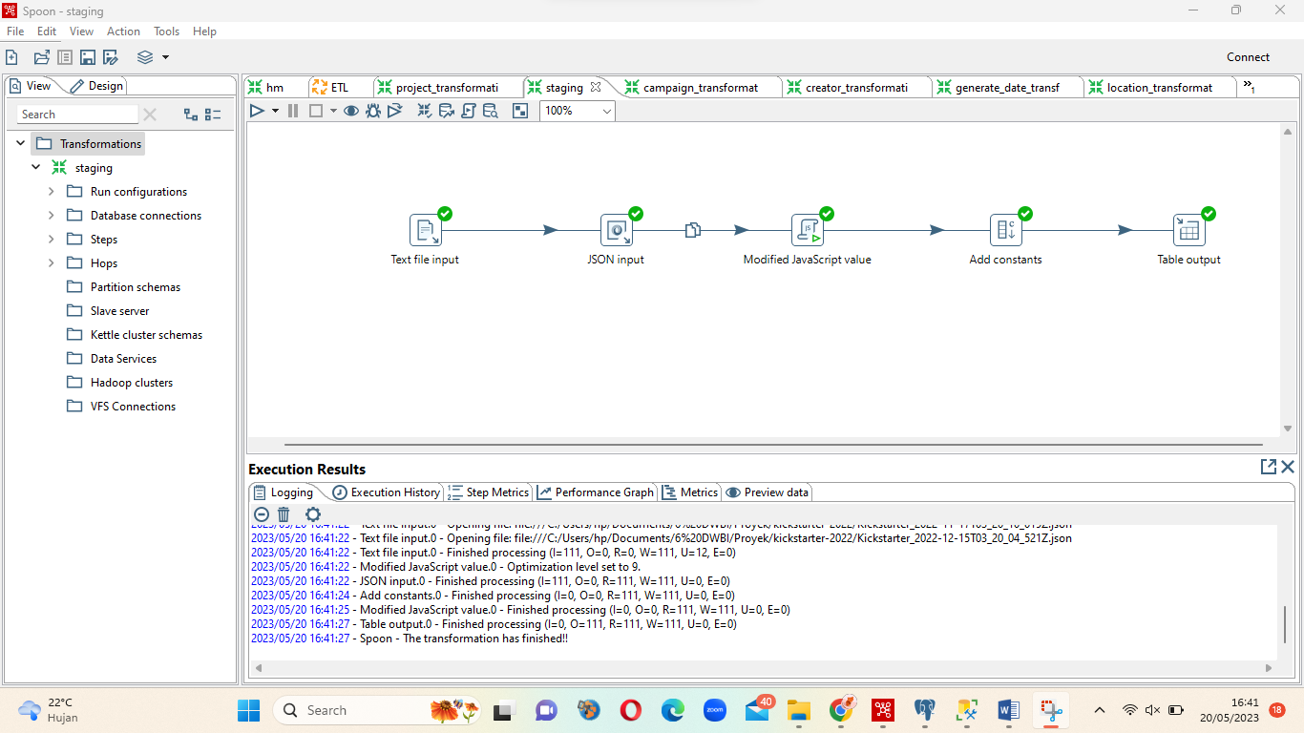

1. Creator_transformation

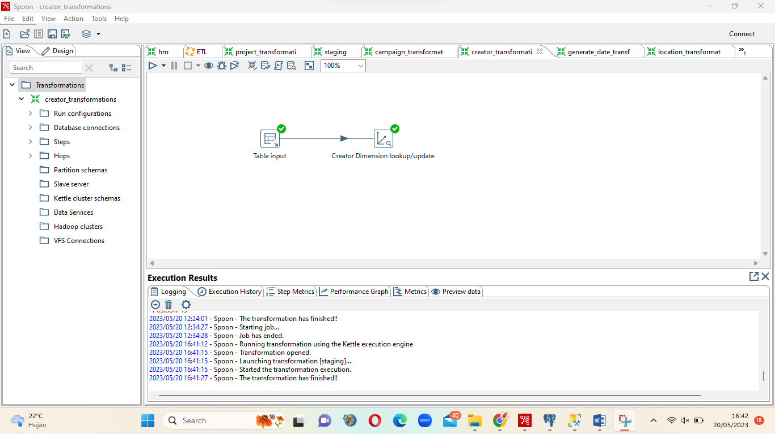

1. Project_transformation

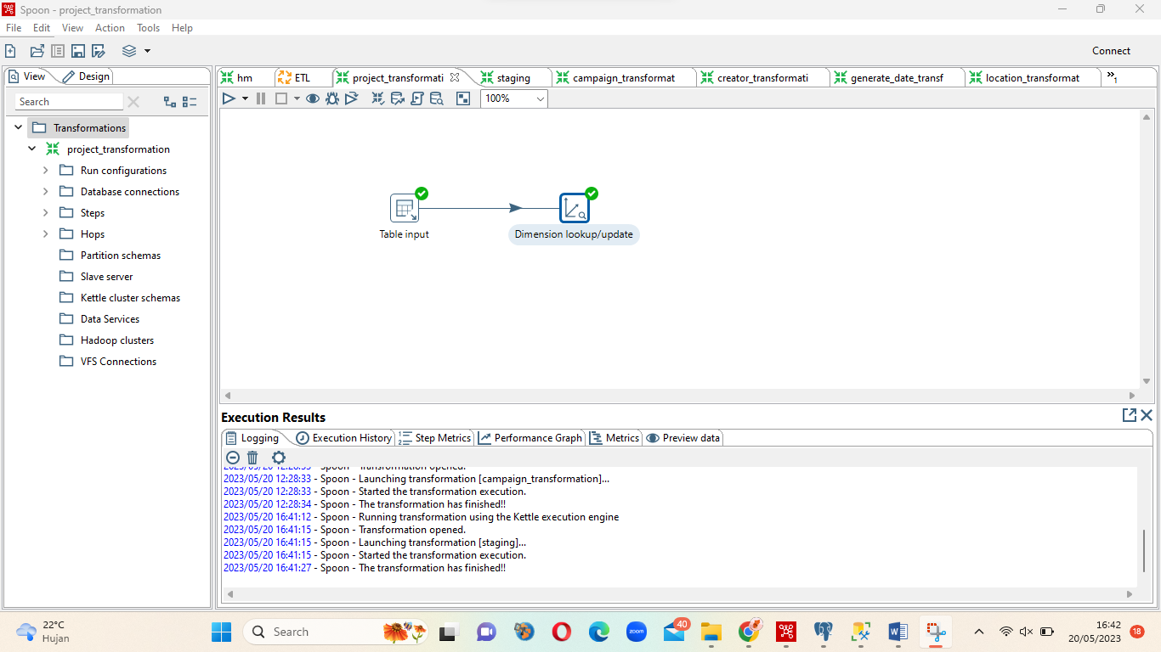

1. Generate_Date_transformastion

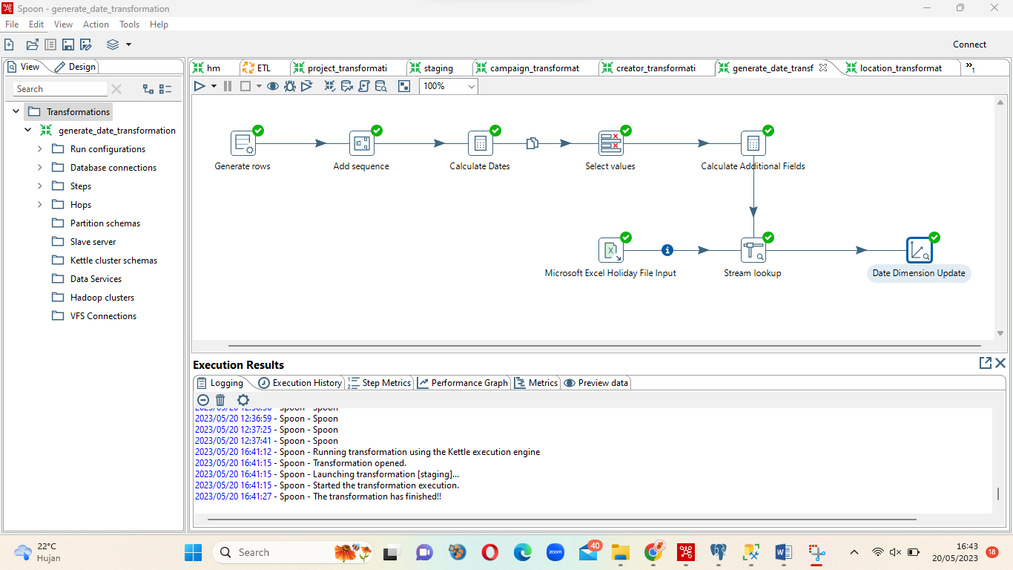

1. Location_transfoemation

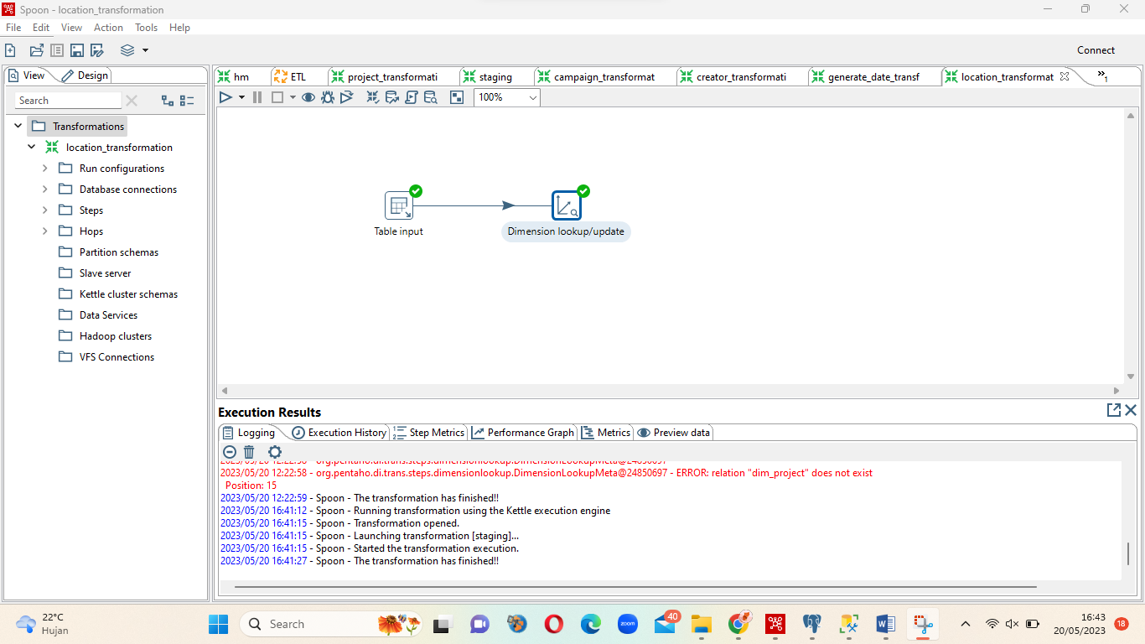

1. Campaign_transformation

